2018 Blue and Gold Banquet

&

Arrow of Light Crossover Ceremony

February 28, 2018

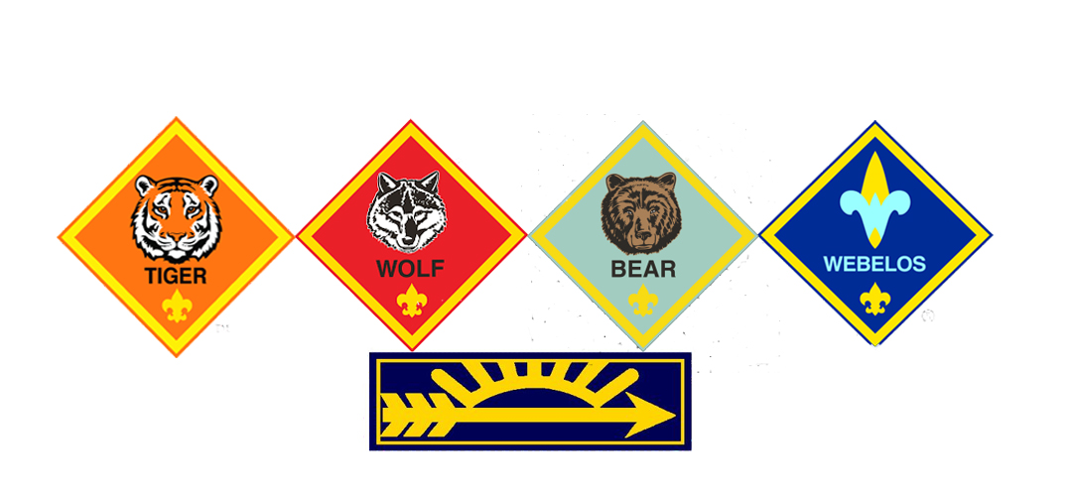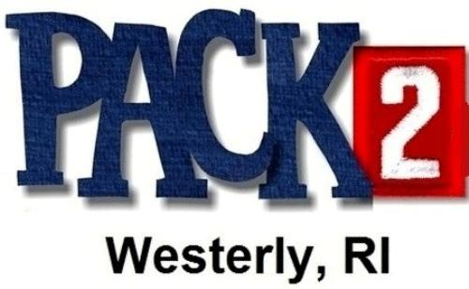

Blue and Gold Committee

Erica Ballesteros, Christen Kazarian

Deb Pendola, Jane Perkins

Jen Whitfield

Pack 2 Leaders

Cubmaster – Joe Kushner

Arrow of Light Den Leader – Aaron Bulger

Webelos Den Leader – Chad Lenihan

Bear Den Leader – Ben Servideo

Wolf Den Leader – Shawn Martin

Tiger Den Leader – Keith Gynther

Advancement Chair – Jane Perkins

Committee Chair – Dan Roy

Committee Member – Jen Whitfield

Charter Organization Rep – Christen Kazarian

All Pack 2 Families

Thank you for supporting Pack 2!

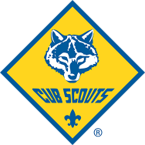

## Special Thanks

Welcome

Presentation of the Colors

Invocation

Dinner

Den Awards

Leader Recognitions

Cub Scouting Birthday

Dessert

Arrow of Light

Crossover Ceremony

Announcements

Closing and Dismissal

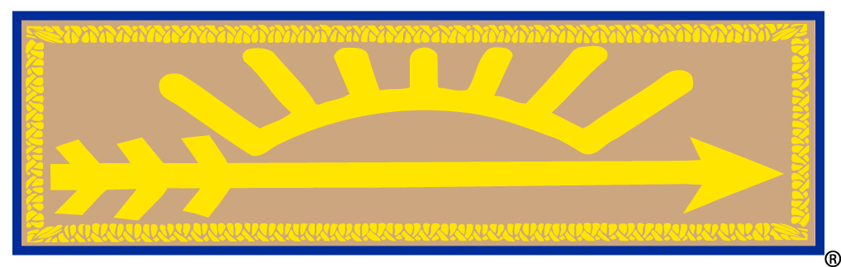

## Order of Events

The highest award of Cub Scouting is the Arrow of Light badge. It is a small cloth badge with a tan background, blue border, and a gold arrow pointing to the right (as viewed from the front) under a partial gold sun orb with 7 rays that is worn on both the Cub Scout and the Boy Scout uniform.

The individual elements of the badge represent:

– The sun shedding its light on all that we do. A reminder that Cub Scouts should be a light for those around them.

– The seven rays of the sun representing the seven days of the week. A reminder that Cub Scouts should do their best every day.

– The arrow which is symbolic of everything which is straight and true. Just as Cub Scouts should be straight and true in their lives. It also points forward to the trail of Boy Scouting ranks and higher challenges.

2018 AOL

Josh Ballesteros

Ben Bulger

Paolo McCarty

Alex Pendola

Chris Pendola

## Arrow of Light

## AOL Recipients